Module 1: Backend Processing System (Flask API)

1. Introduction
This module forms the core of our pothole detection project. Built on the Flask framework, it brings together all the essential pieces from receiving road images to running them through a trained YOLO model and producing results that field teams can actually use. Think of it as the engine that sits between the camera and the decision-maker.
Rather than just returning raw numbers, the backend processes each image and delivers clear, structured information about pothole severity, repair priority, recommended action, and approximate location all in one clean API response.

2. Objective
The module was built with four clear goals in mind:
- Handle road images uploaded by users through a simple API call
- Run those images through a deep learning model trained to detect potholes
- Turn the raw detection data into actionable maintenance insights
- Send back well-organized responses that can be used by a dashboard or any other frontend

3. System Workflow

Step 1: Receiving the Image
When a user sends an image to the /predict endpoint, the system immediately does a quick sanity check. It confirms the file actually exists, the filename is valid, and the format is something we can work with (JPG, PNG, and similar formats). Nothing moves forward until these basics pass.

Step 2: Validating the Input
Before the image goes anywhere near the model, the system enforces a few rules to keep things stable:
- Files cannot exceed 16 MB large uploads get rejected with a clear error
- Only JPG, JPEG, PNG, BMP, WEBP, and TIFF formats are accepted
- If anything fails, the user gets a descriptive error message instead of a cryptic crash

Step 3: Loading the Detection Model
To avoid slowing down every startup, the YOLO model is loaded lazily meaning it only loads the first time it's actually needed. After that, the same model instance is reused for every request, keeping things fast. The model file path (best.pt) is set through a config, so swapping in a new model is straightforward.

Step 4: Preparing the Image
Once the file passes validation, it gets prepared for the model. The raw bytes are read, converted into a proper image using PIL, and normalized to RGB format. The system also records the image's width and height, which come in useful later for mapping out bounding boxes accurately.

Step 5: Running Pothole Detection
The cleaned-up image is fed into the YOLO model. Two key thresholds govern what counts as a detection:
- Confidence threshold (default 0.25) how certain the model needs to be before flagging something
- IOU threshold (default 0.45) controls overlap tolerance when multiple detections appear in the same area
The model returns a list of bounding boxes, the label for each detection (pothole), and a confidence score per detection.

Step 6: Structuring the Predictions
Raw model output isn't the most readable thing, so the system translates it into a clean, structured format. Each detected pothole is described with:
- Its label
- The confidence score
- Bounding box coordinates x1, y1 (top-left) and x2, y2 (bottom-right)
- The width and height of the bounding box
Results are then sorted from highest to lowest confidence, so the most certain detections always appear first.

Step 7: Counting the Potholes
A simple count of all detections is taken at this point. This number feeds directly into the severity and priority calculations that follow.

Step 8: Calculating Severity
Severity is rated on a 0–5 scale and reflects both how many potholes were found and how confident the model was about them:
- A higher pothole count pushes the severity score up
- High model confidence nudges the severity up slightly further
This gives field teams a quick read on how serious the road damage is without having to dig into the raw numbers.

Step 9: Assigning a Priority Score
The priority score (0–100) tells maintenance teams which roads need attention most urgently. It's calculated as a weighted blend:
- Severity accounts for 70% of the score
- The raw pothole count makes up the remaining 30%
This weighting ensures that both the intensity of damage and its spread are factored into prioritization.

Step 10: Recommending a Repair Type
Based on the severity rating, the system suggests the most appropriate repair approach:
- Severity 1–2: A minor patch will do the job
- Severity 3–4: A partial repair is recommended
- Severity 5: Full-depth repair is required
Along with the repair type, the system estimates a cost calculated per pothole and scaled by the total count, with a bit of realistic variance built in.

Step 11: Generating a Location
Because real-time GPS isn't available in this setup, the system generates approximate coordinates using Bengaluru as the base location, with a small random offset to simulate realistic variation. This placeholder keeps the API response complete and ready for when actual GPS integration is added.

Step 12: Building the Final Response
Everything comes together in a clean JSON response that includes all the information a maintenance team or dashboard would need:
- Image metadata
- List of pothole detections with coordinates and confidence scores
- Total pothole count
- Severity rating
- Priority score
- Recommended repair type
- Estimated repair cost
- Latitude and longitude for mapping

4. API Endpoints

4.1 Health Check GET /health
This endpoint lets you quickly confirm that the server is up and the model is ready. It returns the API status, whether the YOLO model has been loaded, and the model file path. Useful for monitoring and deployment checks.

4.2 Prediction POST /predict
This is the main endpoint where the work happens. You submit an image as form-data (key: image), with optional confidence and IOU threshold parameters if you want to override the defaults. The response includes all detection results, severity and priority metrics, a repair recommendation, and location data.

5. Error Handling
The system is designed to fail gracefully. Every common error scenario is covered with a clear, appropriate HTTP status code:
  - 400 – Bad request (invalid file or parameters)
  - 404 – Endpoint not found
  - 405 – HTTP method not allowed
  - 413 – File too large (over 16 MB)
  - 500 – Something went wrong internally
  - 503 – Model couldn't be loaded

6. Logging and Debugging
Python's built-in logging module is used throughout the backend. Key events — like when the model loads successfully, or when something goes wrong during inference — are all recorded. This makes tracking down issues much easier during development and after deployment.

7. Performance Considerations
A few deliberate choices were made to keep the system fast and responsive:
- The model loads lazily, so startup time stays low
- Images are processed in memory rather than saved to disk first, cutting unnecessary I/O
- Both the confidence and IOU thresholds are configurable, so you can tune the trade-off between detection accuracy and speed without touching the code

8. Technologies Used
- Python — primary language
- Flask — lightweight backend framework
- Ultralytics YOLO — object detection model
- PIL (Pillow) — image handling and preprocessing
- Flask-CORS — cross-origin request support for frontend integration

9. Conclusion
This backend module does a lot of heavy lifting in a relatively clean package. By combining machine learning-based detection with structured analytical logic severity scoring, priority ranking, and repair recommendations it turns a simple image upload into a genuinely useful output for road maintenance teams. It's built to be fast, adaptable, and easy to extend as the project grows.

Module 2: System Integration & Backend Pipeline Report

1. Introduction
Building individual components is one thing making them work together smoothly is another. This module is all about the second part. It ties together every analytical piece of the pothole detection system into a single, coherent pipeline that takes a raw image and turns it into a concrete maintenance recommendation, without any manual handoffs in between.

2. Objective
The integration layer was designed to solve three real problems:
- Multiple modules doing different jobs need to share data without losing anything along the way
- The pipeline should run automatically, without someone manually triggering each stage
- The outputs need to be reliable and prioritized enough that a maintenance team can act on them directly

3. System Architecture Overview

3.1 How the Pipeline Flows
The system runs sequentially each stage hands off its results to the next. Here's what happens in order:
- Pothole Detection (YOLOv11): The starting point. The model scans the uploaded image and identifies every pothole it can find.
- Severity Analysis: Takes the detection results and evaluates how serious the damage is, producing a severity rating.
- Formation Analysis: Looks at the pattern of damage to infer likely causes things like drainage failure, heavy vehicle wear, or surface aging.
- Deterioration Prediction: Uses the current condition to forecast how quickly things will get worse if left unaddressed.
- Priority Calculation: Pulls everything together severity, traffic load, environmental factors to produce a final maintenance priority score.

4. Backend Pipeline Implementation

4.1 The Central Handler (app3.py)
Everything flows through app3.py. This file is the backbone of the pipeline it receives the incoming request, passes the image and data through each module in sequence, collects the results, and assembles the final JSON response that gets sent back. Nothing is hardcoded to a specific module; the handler is designed to be extended as new analytical components are added.

4.2 Keeping Modules in Sync
Getting multiple modules to talk to each other reliably took some careful engineering. A few key design choices make this work in practice:
- Data is passed cleanly between stages, with the output of one module feeding directly into the next
- If a module receives incomplete or missing data, it falls back to safe default values rather than crashing the whole pipeline
- API failures at any stage are caught and handled, so a problem in one module doesn't bring down the entire workflow
- The pipeline stays stable even under partial failures — it degrades gracefully and continues where it can

5. External API Integration

5.1 Weather Data
Weather plays a bigger role in road damage than most people realize. The pipeline pulls live weather data from the OpenWeatherMap API to factor in environmental conditions things like recent rainfall or temperature extremes when predicting how quickly a pothole is likely to deteriorate.

5.2 Traffic Data
A pothole on a quiet backstreet is a very different priority from one on a busy arterial road. Traffic volume data from the OpenStreetMap API helps the system weight priority scores based on how much daily use a road actually sees.

5.3 Handling API Failures
External APIs go down. That's a fact of life. To handle this, both integrations have default fallback values built in, so the pipeline doesn't stall waiting for a response that may never come. Error recovery logic ensures the rest of the pipeline keeps running even if one external call fails.

6. Testing Framework

6.1 End-to-End Testing with test_pipeline.py
A dedicated test script covers the full pipeline from start to finish. Rather than testing each module in isolation and hoping they work together, this script simulates a real request and validates the output at every stage. It's been essential for catching integration bugs that unit tests would miss, and for tuning the pipeline's behavior before deployment.

7. Quality Assurance & Debugging

7.1 Catching and Correcting Bias
During testing, we noticed the Formation Analysis module was flagging drainage-related causes far more often than the data actually supported. This kind of systematic over-prediction can skew prioritization and send repair teams in the wrong direction. Once identified, corrective logic was introduced to rebalance the outputs and produce more accurate, fair assessments.

7.2 Improving Accuracy Across the Board
Beyond the bias fix, several targeted improvements were made based on test results:
- The Formation Analysis module was refined to better distinguish between different damage causes
- The Deterioration Prediction model was tuned to produce more realistic forecasts
- Final output scores were adjusted to better align with real-world maintenance priorities

8. Technical Stack
- Python — the primary programming language across all modules
- Flask — the backend framework managing request handling and routing
- PyTorch (YOLOv11) — the deep learning framework powering object detection
- OpenWeatherMap API — live weather data for deterioration analysis
- OpenStreetMap API — traffic data for priority scoring
- Custom Python scripts — for testing and pipeline validation

9. Conclusion
Putting all these modules together into a single, working pipeline was the hardest part of this project and the most important. The integration layer ensures that good detection results don't just sit in isolation; they flow through analysis, prediction, and prioritization to produce something a maintenance team can actually act on. With robust error handling, external data integration, and thorough testing behind it, this pipeline is built to run reliably in the real world.
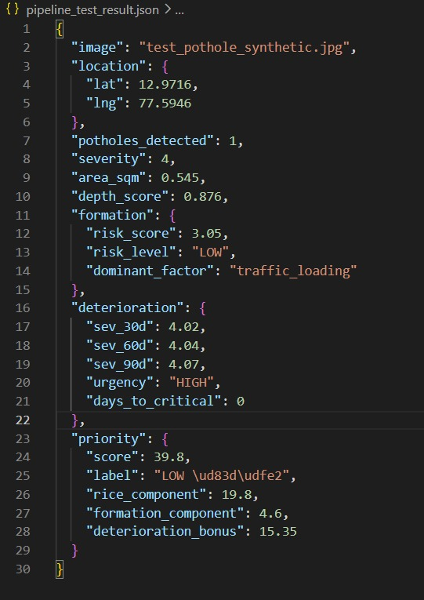

Module 3: Location Extraction — final_dashboard.html

1. Overview
When a file is uploaded, the dashboard automatically attempts to determine GPS coordinates using a four-level priority chain. Automatic extraction is tried first; if it fails the user is prompted to enter coordinates manually or accept a Bengaluru city-centre default.

Priority Chain
Priority | Method | Source Tag | Trigger
1 — Highest | EXIF GPS tags | source: 'exif' | Image file uploaded
2 | ISO 6709 in video binary | source: 'video' | Video file uploaded
3 | Manual user entry | source: 'manual' | Auto-extraction returns null
4 — Fallback | Bengaluru default | source: 'default' | User clicks Use Default

2. Default Location
A constant fallback used only when all automatic methods fail and the user explicitly clicks Use Default. Never applied silently.
const DEFAULT_LOCATION = { lat: 12.9716, lng: 77.5946, source: 'default' };
Coordinates: Bengaluru city centre. Precision ~100 m.

3. DMS to Decimal Conversion — dmsToDecimal(dms, ref)
EXIF stores GPS as three rational numbers (Degrees / Minutes / Seconds). This helper converts them to a single signed decimal degree value.

Parameters
Parameter | Type | Description
dms | Array[3 rationals] | {numerator, denominator} objects for degrees, minutes, seconds
ref | String | 'N' or 'S' for latitude · 'E' or 'W' for longitude

Formula
dd = degrees + (minutes / 60) + (seconds / 3600)
if ref === 'S' or 'W': dd = -dd
returns null if dms is malformed or has fewer than 3 elements

4. Image GPS — extractExifGPS(file)
Reads EXIF metadata embedded in JPEG, PNG, and WEBP files using the exif-js library loaded as a script tag in the page.

Execution Steps
Step | Action
1 | Create an object URL from the file and load it into a temporary img element.
2 | Call EXIF.getData() to parse the image EXIF block asynchronously.
3 | Read GPSLatitude, GPSLatitudeRef, GPSLongitude, GPSLongitudeRef tags.
4 | Optionally read GPSAltitude and GPSAltitudeRef (metres, negative below sea level).
5 | Convert DMS arrays to decimal degrees via dmsToDecimal().
6 | Revoke the object URL to free memory.

Return Value
{ lat: 12.93775, lng: 77.62763, alt: 921.4 } // alt is null if absent
Returns null if: exif-js not loaded · no GPS tags present · DMS conversion fails.
If typeof EXIF === 'undefined' the function resolves null immediately without throwing, so a missing CDN load degrades gracefully.
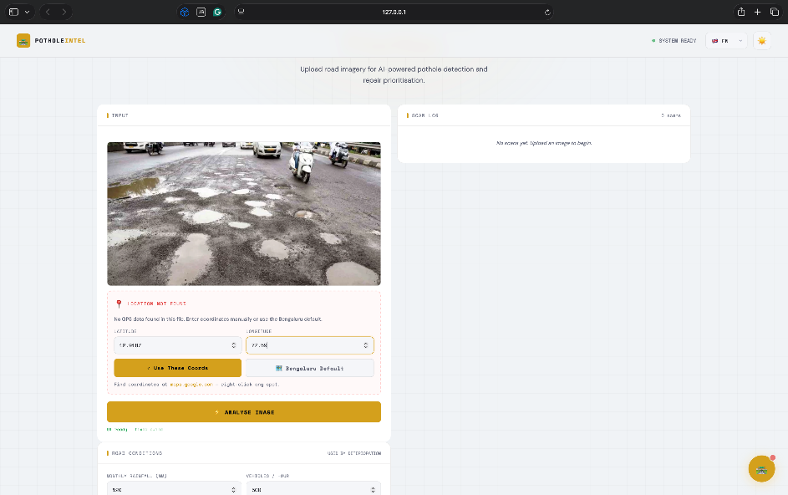

5. Video GPS — extractVideoGPS(file)
Videos do not carry EXIF. GPS is stored as an ISO 6709 coordinate string in the MP4/MOV binary container. Only the first 128 KB is scanned because GPS metadata always appears near the start of the container.

Execution Steps
Step | Action
1 | Slice the first 131,072 bytes: file.slice(0, 131072).
2 | Decode bytes as UTF-8 using TextDecoder (non-fatal mode for binary safety).
3 | Run regex to find ISO 6709 pattern: ([+-]d{1,3}.d{2,8})([+-]d{1,4}.d{2,8})
4 | Parse matched groups as floats.
5 | Validate: both values finite · |lat| <= 90 · |lng| <= 180.

Return Value
{ lat: 12.93775, lng: 77.62763 } // altitude not available from video
Camera support: iOS Camera and some Android cameras embed GPS. Screen recordings and downloaded videos will not have it.

6. Location Resolution — resolveLocation(file, isVideo)
Orchestrates the extraction chain and returns a tagged location object or null.
async function resolveLocation(file, isVideo) -> { lat, lng, source } | null

isVideo | Behaviour | source tag
false | Tries EXIF only. Returns null if no EXIF GPS found. | 'exif'
true | Tries video binary scan only. Returns null if not found. | 'video'

A null return triggers the manual entry form. Browser geolocation (navigator.geolocation) is not currently invoked — see Known Limitations.

7. Manual Entry Fallback — showManualForm()
Shown when resolveLocation() returns null. Returns a Promise that resolves once the user submits valid coordinates or accepts the default.
function showManualForm() -> Promise<{ lat, lng, source }>

Validation Rules
Field | Rule
Latitude | Must be a finite float · -90 <= lat <= 90
Longitude | Must be a finite float · -180 <= lng <= 180

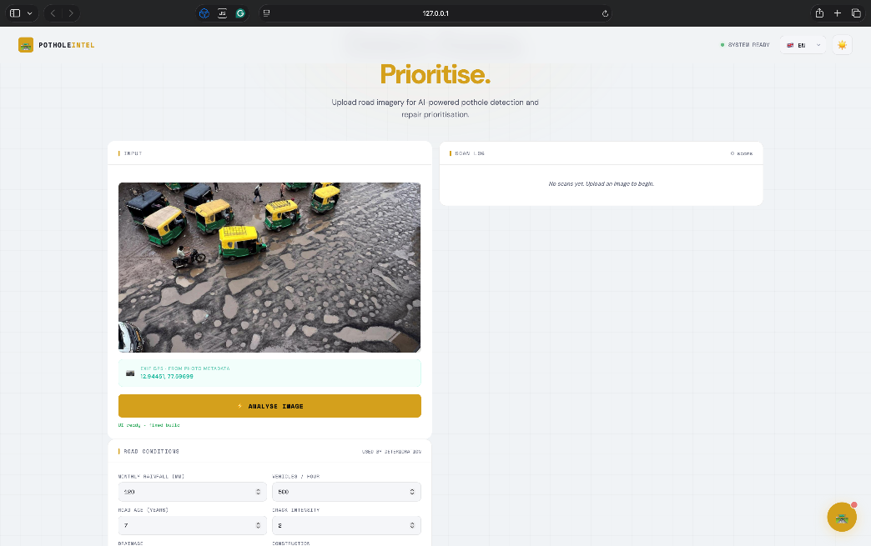
Invalid fields receive the CSS class input-error (red border). Enter key on either input triggers the Confirm button.

8. Location Badge UI
After any successful resolution, showLocationBadge(locResult) updates the badge shown below the image preview. Coordinates are displayed to 5 decimal places.

source | Icon | Badge Colour | CSS class
exif | ■ | Teal | source-exif
video | ■ | Yellow | source-video
gps | ■ | Green (reserved) | source-gps
manual | ✏ | Yellow | source-manual
default | ■ | Red | source-default

9. How Coordinates Reach the Backend
After resolution, coordinates are stored in resolvedLocation and appended to the FormData sent to /predict and /formation:
const fd = new FormData();
fd.append('image', file);
fd.append('lat', position.lat);
fd.append('lng', position.lng);
fetch('/predict', { method: 'POST', body: fd });

The backend (app.py) reads these via get_coords(request.form). If both lat and lng are absent, it falls back to BASE_LAT=12.9716, BASE_LNG=77.5946 (set in .env).

10. Known Limitations
Limitation | Detail
EXIF stripped by messaging apps | Images shared via WhatsApp, Telegram, or social media have EXIF removed. Manual entry will be triggered.
Video GPS coverage | Only iOS Camera and some Android cameras embed GPS. Screen recordings and downloaded videos will not have it.
No browser geolocation | source:'gps' is defined but resolveLocation() never calls navigator.geolocation. Real-time device GPS is not currently used.
WEBP EXIF support | exif-js has limited WEBP support. May return null for WEBP files even when GPS tags are present.
Video altitude | Altitude is not extracted from video container metadata; only lat/lng are parsed.

